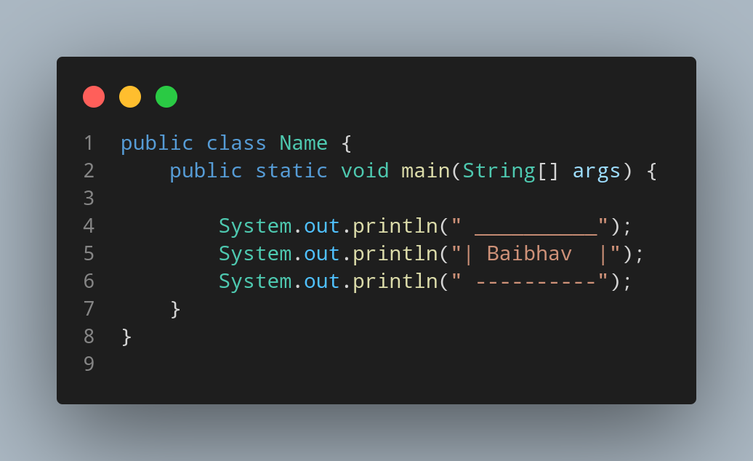

#Doc

File name Name is created so we create a class name Name, inside the class, we created a main function. The main function only contain print function that print the spaces and symbols that are structured like Box to print box made up of symbol and space along with my name, lokking like name inside a box.

